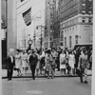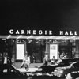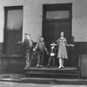

Reception at the Fraser Gallery
Lida Moser, Photographer – Fifty Years of Photographs
March 18, 2005
MAM 599 Art Gallery Management
Debra Smyers

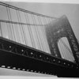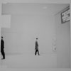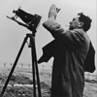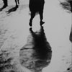

Georgetown is the place to be on the third Friday of the month. This is when many of the galleries host their receptions for their new monthly exhibits and the artists are present for the public to meet. Complimentary food and beverage is offered and the people that attend are usually from the “in the know” arts circle. It is an evening for the unveiling of new exhibits and meeting the artists, a chance to unwind from a long week, and a fun social interaction with other art enthusiasts. Networking naturally takes place as one meets artists, writers, publicists, other professionals from all career fields, and just regular folk that are all great to talk with.
As we arrived at 6 p.m. outside of the Fraser Gallery, some type of yoga movement or creative dance was being performed by a group of about eight people, all different ages. Several people were taking pictures, and obviously this was some form of art that was taking place. It did set a creative mood and a wondering of what the night may have in store.
I chose the Fraser Gallery to visit simply from their excellent website, and I thought the exhibit would prove interesting for my husband and I to enjoy. At 6:06 we entered the gallery to meet a dashingly handsome and charming, F. Lennox Campello (Lenny), the co-owner of the gallery. He welcomed us and drew us in, in a hospitable fashion as he was putting the finishing touches for the reception. Any other person may have looked hurried or unprepared, but not Lenny as he turned on the festive music and began slicing the oranges for the sangria; he just made one feel at home.
We talked about “arts nights” in the different surrounding communities. We spoke of Alexandria and we both wondered if a Friday night would be better than Thursday for their festivities. Lenny said, “You know the fourth Friday of the month is open, perhaps Alexandria could try that.” Lenny explained that he and his ex-wife are co-owners of the Fraser Gallery with two locations: one in Georgetown and the other Bethesda. He pointed to a box and said he had more photographs than he could hang and that he was waiting for a display case to arrive. He remarked that the Bethesda location was much larger and that he always seemed short on space in Georgetown. The display case did not arrive, but the portfolio was displayed which added about another 20 photographs, now totaling 45 for the public to view.
Lenny exuberantly spoke of the night’s event. “Lida Moser is 86 years old and will be arriving shortly. Recently she has come out of retirement because of a renewed interest in her work.” In the 1940’s Lida Moser was a street photographer in New York City and worked for many magazines including Vogue, Look and Harpers Bazaar. She was truly a pioneer in photojournalism and her collections are in many museums worldwide. She averages about $4,000 a photograph at Christie’s. Lenny speaks about pricing artwork and says that he likes to ID and list the price for the artwork in his studio. “It diffuses the awkwardness and the fear of asking the price for his customers.”
My husband and I began perusing the 25 photograph exhibit hung closely side by side against bright white walls over the entire circumference of the room. When I mentioned my favorite (“5th Avenue & 19th Street in 1949”) Lenny laughed and said “yeah that was before it was a one way street.” Up to this point, Lenny was the storefront opener, the food arranger, and the friendly host. A received phone call turned him into an art broker role very quickly. One of the pieces of photography on the wall was being negotiated for sale. Lenny approached the work very closely and admitted that there was a half inch cut in the mat. He offered to have it rematted and said it would be a month before the client received it. The listed price of $3,500 was held firm and a sale presumably was made.
Lenny quickly then returned to host, found some cups and began pouring a very strong sangria as guests arrived.
The guest of honor, Lida Moser arrived about 6:30. Her appearance was somewhat fragile, but her personality lit the room up with color against all the black and white photographs. She immediately pointed out her favorite: “Office Building Lobby New York, 1965.” “It’s so New York. Isn’t it marvelous? It shows the sterility of the workplace in New York.”
Someone interrupted Lenny with excitement asking if Lida Moser was still alive. Lenny said “I hope so, because she’s right here”, and everyone laughed and the sangria began flowing. People began socializing. Of course Lida was fascinating to talk to. She recounted her days in New York City and said that ‘I photographed what I liked. I was not critical.” She mingled with the guests and then took a nice comfortable chair from which she spoke to individual people.
Catriona Fraser the other co-owner of the Fraser Gallery arrived about this time. She was impeccably dressed in a black suit, reserved, strictly business and spoke with a gorgeous British accent. She really didn’t mingle but she gave the sense of a true professional. She kept the trays of finger food neat which were served from the desk which effectively saved space and brought people all the way in to the back wall of the gallery. It appeared that she was handling some sales and paperwork for the evening. Both Catriona and Lenny are artists and their works displayed on their website are very interesting and accomplished.
During the mingling my husband (a career military officer) and I met Michael Brodhead a writer of at least six books. It was interesting to hear how he had meshed his military career in the Corps of Engineers with his love of art and talent in writing. He was fascinated by art and had taken many art history classes and mentioned several of his mentors. He carved out a writing career in art and history in addition to his military service. Lenny, too, served in the military for many years while he was creating artwork, and he retired as a well decorated navy commander and acclaimed artist.
The entire evening was enjoyable and several pieces were sold. Lida complimented Lenny in his choices for the gallery from among her many photographs, and having them framed and displayed so nicely. They were lovely, and the lighting in the gallery enhanced their visual beauty and the matting and framing complimented the photographs. The two owners were perfect hosts and their pristine studio has quite a following. Their different personalities were appreciated and their knowledge of art, along with their own artistic talents, was impressive. They definitely spotlighted Lida Moser’s work and hosted a wonderful evening for all.

Gallery Openings
Tonight is the 3rd Thursday gallery crawl around the 7th street corridor. From 6-8PM in most places. Especially interesting seems Carolina Sardi: Over/Under, curated by Rody Douzoglou at Flashpoint. Also Numark Gallery has Shimon Attie: The History of Another, which is well-worth the visit tonight.
Tomorrow, it's the turn of the Canal Square Galleries in Georgetown, as we will all have our new shows opening or extended hours and the openings will be catered by our Canal neighbor, the Sea Catch Restaurant. Elsewhere in Georgetown, Addison Ripley will have the wonderfully busy watercolors of Patricia Tobacco Forrester.
Especially interesting in the Canal Square Galleries is MOCA's Erotic Art Show, a jumble of dozens of artists exploring the moist avenues of erotica.
We will have the brilliant photographs of Lida Moser. This is probably our most important photography show of the year.
Opening tomorrow night and through April 13, 2005, our Fraser Gallery in Georgetown will be hosting the first ever Washington, DC solo exhibition of legendary American photographer Lida Moser, who now lives in retirement in nearby Rockville, Maryland.
This 85-year-old photographer is not only one of the most respected American photographers of the 20th century, but also a pioneer in the field of photojournalism. Her photography is currently in the middle of a revival and rediscovery, and has sold as high as $4,000 in recent Christie's auctions and continues to be collected by both museums and private collectors worldwide. In a career spanning nearly 60 years, Moser has produced a body of works consisting of thousands of photographs and photographic assemblages that defy categorization and genre or label assignment.
Additionally, Canadian television is currently in the process of filming a documentary about her life; the second in the last few years, and Moser’s work is now in the collection of many museums worldwide.
A well-known figure in the New York art scene of the 1950s, 1960s, and 1970s,a portrait of Lida Moser by American painter Alice Neel hangs in the permanent collection of the Metropolitan Museum in New York City. Neel painted a total of four Moser portraits over her lifetime, and I believe that one of them will be included in the National Museum of Women in the Arts' "Alice Neel's Women" coming to Washington, DC this October.
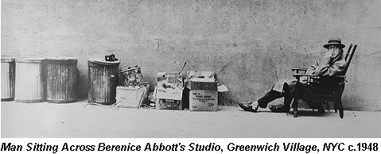
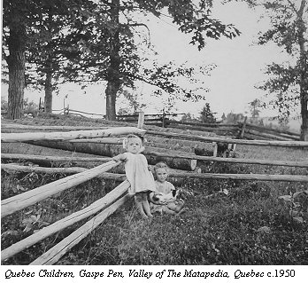
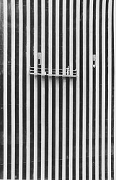
Lida Moser's photographic career started as a student and studio assistant in 1947 in Berenice Abbott's studio in New York City, where she became an active member of the New York Photo League. She then worked for Vogue, Harper's Bazaar, Look and many other magazines throughout the next few decades, and traveled extensively throughout the United States, Canada and Europe.
In 1950 Vogue, and (and subsequently Look magazine) assigned Lida Moser to carry out an illustrated report on Canada, from one ocean to another. When she arrived at the Windsor station in Montreal, in June of that same year, she met by chance, Paul Gouin, then a Cultural Advisor to Duplessis government. This chance meeting led Moser to change her all-Canada assignment for one centered around Quebec.
Armed with her camera and guided by the research done by the Abbot Felix-Antoine Savard, the folklorist Luc Lacourcière and accompanied by Paul Gouin, Lida Moser then discovers and photographs a traditional Quebec, which was still little touched by modern civilization and the coming urbanization of the region. Decades later, a major exhibition of those photographs at the McCord Museum of Canadian History became the museum’s most popular exhibit ever.
She has also authored and been part of many books and publications on and about photography. She also wrote a series of "Camera View" articles on photography for The New York Times between 1974-81. Her work has been exhibited in many museums worldwide and is in the permanent collection of the National Portrait Gallery, London, the National Archives, Ottawa, the National Galleries of Scotland, National Portrait Gallery, Washington, DC, the Library of Congress, Les Archives Nationales du Quebec, Corcoran Gallery, Phillips Collection and many others. Moser was an active member of the Photo League and the New York School.
The Photo League was the seminal birth of American documentary photography. It was a group that was at times at school, an association and even a social club. Disbanded in 1951, the League promoted photojournalism with an aesthetic consciousness that reaches street photography to this day.
This will be her first solo exhibition in Washington, DC and it will run from March 18 through April 13, 2005.
An opening reception for Ms. Moser will be held tomorrow night, Friday, March 18, 2005 from 6-9PM as part of the third Friday openings in Georgetown. The reception is free and open to the public.

